Capstone Project Prospectus and Registration information
Spring 2021
Students:
ID | Last name ('family') |  | First name ('private') | e-mail
205717077 | Golan |  | Saar | Saar.Golan@e.braude.ac.il
316216571 | Nadler |  | Roni | Roni.Nadler@e.braude.ac.il
Category: |  | research | Date of submission for registration:

Supervisor' approval:
Name: Miri Weiss Cohen
E-mail: miri@braude.ac.il

Skeleton Motion Detection With Deep Learning

Prospectus
Synopsys:
Nowadays, healthcare centers are not familiar with quantitative approaches for patients’ gait evaluation. Hence the need for detailed human gait detection system. Human gait refers to the various locomotion of a human using their limbs. A gait evaluation depends on various parameters.
Our research project aimed to provide a method to obtain skeleton figures characterizing patients’ gait performance via Deep Learning. The project is based on YOLO algorithm for human gait detection. YOLO is a real-time object detection method, introduced for motion detection in complex scenes.

Scope of the project:

The project is designed to provide identification and classification of patient's proper gate using Deep Learning. In order to assess patient's gait we use the parameters described in the following table.
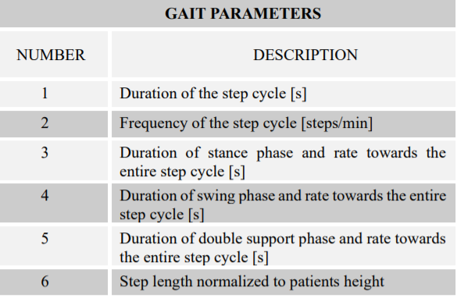

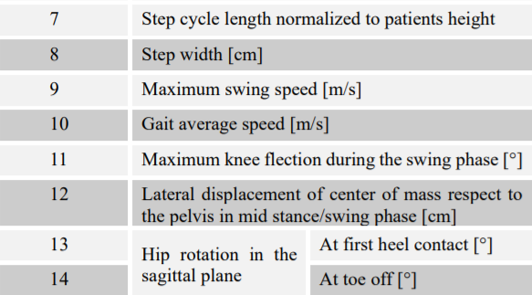
As part of the project, we will develop an application that is able to take as input RGB video and automatically generate skeleton figures characterizing patients’ gait performance.

The project focuses on several technologies:
- YOLOv4 – real time object detection system featured by the Darknet framework (open source neural network framework).
Some of the technological challenges involved are:
The exploratory work required for this project includes:
- Gait analysis – considering the parameters in the table above and skeleton anatomy structure.
- Deep Learning for skeleton-based gait recognition
- YOLO based CNN object detection on video files.

Unique features:

This is a unique project that use Deep Learning to analyse patient's gait and the quality of it by making it measurable. Thus, using a simple RGB camera only allows healthcare centers to assemble an accurate and faster rehabilitation plan for patients.

